Vanguard Laundry: Giving social impact a voice
This case study is designed to help those interested or engaged in impact measurement. It provides insights into the learnings from the development and ongoing evolution of Vanguard Laundry’s Outcome and Impact Measurement (OIM).

Key take outs
- Vanguard Laundry have made their Impact Reports available to the wider social impact investing sector.
- The evidence from Vanguard’s Impact Reports has helped promote the potential of other social impact organisations.
- In particular, Vanguard’s Impact Reports demonstrate the value of reporting on outcomes to support investor funding decisions as they serve both as a success story that boosts investor confidence and a guide to potential social enterprises seeking funding.

About Vanguard Laundry
Vanguard Laundry is a social enterprise laundry service operating in Toowoomba, Queensland, and surrounding areas. It was established in 2016 with the aim to support its broader social mission through operating a sustainable, profit-making commercial laundry business. It provides supported employment pathways for people with a lived experience of social disadvantage, who have a history of long-term unemployment - known as target staff. The enterprise offers direct employment opportunities within the laundry and hosts an in-house Social Impact Centre to support staff transition to other employment, education, or training.
Vanguard Laundry’s mission is to build a positive, open employment environment that supports pathways from unemployment to a sustained livelihood. Vanguard provides supported employment opportunities for target staff to gain experience in employment and acquire new skills. These opportunities enable target staff to transition to other employment paths outside of Vanguard Laundry. They promote economic inclusion and generate positive attitudinal shifts in the broader community about people with a lived experience of social disadvantage.

Investing in measuring impact
In 2017, Vanguard Laundry partnered with the Centre of Social Impact at Swinburne University to undertake an evaluation of Vanguard’s social impact. The partnership has been ongoing, with four annual evaluation reports being produced to date.
The evaluation is driven by a Theory of Change which identifies the intended impacts of Vanguard’s activity across four domains: people, place, profits, and the social enterprise ecosystem.

Vanguard Laundry Intended Impacts

People
- Improving the lives of Vanguard participants and their relationships/communities
- Improved long-term economic participation of people with an experience of social disadvantage
- Improved long-term employability of Vanguard staff
- Creating cultural change around who can work

Place
- More socially cohesive communities in which we work
- A stronger local economy

Profits
- Surplus to reinvest into sustainability and purpose
- A model that can be sustainably replicated or expanded

Social Enterprise Ecosystem
- Improved sustainability and reduced volatility of the social enterprise ecosystem
Source: Vanguard Laundry Evaluation Plan 2021
As stated in the third Evaluation of Vanguard Laundry Services, “The aims of the Vanguard Laundry evaluation are to evaluate the individual and community social, economic, health and wellbeing impacts of Vanguard Laundry over time, in relation to Vanguard’s social mission”.

Supporting the ecosystem
Vanguard’s Theory of Change was revised in 2021 to reflect the learnings from the previous three evaluation reports and Vanguard’s broader focus of supporting people who had been locked out of the labour market due to various experiences of social disadvantage. This represented an expansion beyond the initial focus on people with a lived experience of mental illness.
One of the changes made was refining the fourth area of impact, which originally focused on policy and sought to support “better policy frameworks for social and economic participation of people with mental illness”. Following several years of operating the social enterprise, Vanguard management, in collaboration with the Centre for Social Impact at Swinburne University, amended this area to focus more directly on the impact they could have on the social enterprise ecosystem.
As set out in the 2021 Vanguard Laundry Evaluation Plan:

If Vanguard Laundry
- model, reinforce and expand a different approach to work participation of people with experience of social disadvantage

By
- measuring and communicating impacts
- documenting operations and learning

It will lead to learnings that contribute to
- increased and more effectively targeted funding within the social enterprise ecosystem
- the development of sustainability social enterprises

And ultimately
- improved sustainability and reduced volatility of the social enterprise ecosystem.
This change makes explicit the expectation that Vanguard would share documentation and learnings from their OIM activity with the wider social enterprise sector to support the ongoing sustainability of the sector.
Learnings have been shared with the sector over the past four years with a 2 to 3 page snapshot summary Impact Report being made available publicly. More recent findings from OIM activity have been shared in an email newsletter ‘The Quarterly Wash,’ which is sent to clients, supporters and the wider sector.
For Vanguard management, sharing their Impact Reports is important in ensuring that Vanguard’s investment in OIM can be used by other social impact organisations. They understand that not all social enterprises may be at a stage where they are able to invest in similar levels of rigorous, longitudinal OIM activity like Vanguard, and therefore want to ensure that the evidence that has been produced is available and can help develop the sector.
Mark Gates, the Chief Executive Officer at Vanguard Laundry stated “The main reason for sharing our Impact Report was for the benefit of the sector more holistically. If we can take learning from Vanguard as we’ve scaled in Toowoomba and other markets, then we can share them to other work-integrated social enterprises, they will be able to also scale their organisations quicker and be more successful in that process.”

Impact Report snapshots
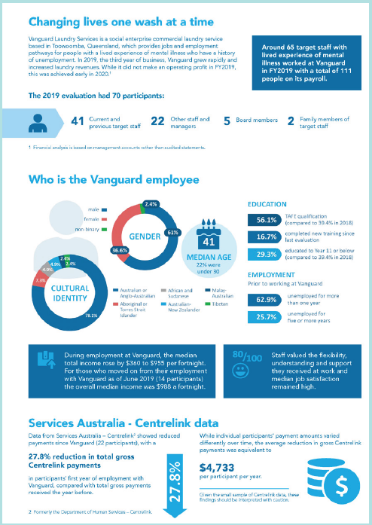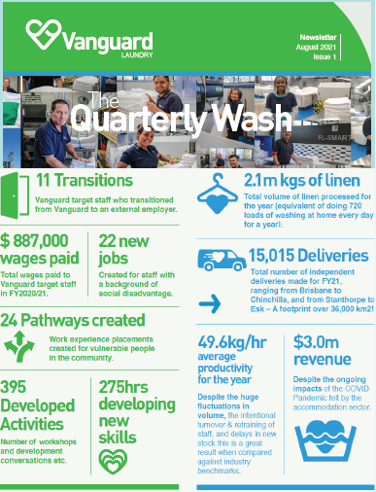

Email newsletter snapshot

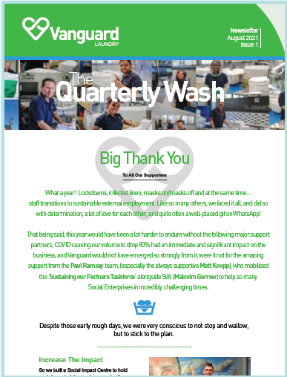

Evaluation snapshot
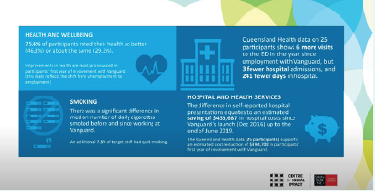

Evaluation summary video snapshot
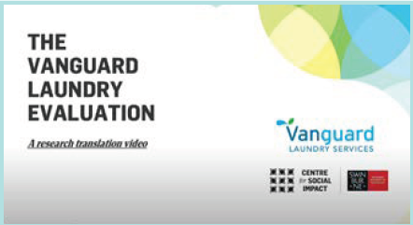
The evidence within Vanguard’s OIM reporting has been used by:

Social Impact Funders
While Vanguard’s Impact Reports provide funders information to support their funding decisions, the rigorous evidence produced over the multi-year evaluation has also played a wider role in helping funders see the value of investing in OIM. It has showcased how evidence can be used to strengthen social impact organisations and therefore maximise the funding provided.

Social Impact Organisations
Other social impact organisations have been able to reference Vanguard’s Impact Reports as an exemplar of the type of outcomes that can be measured, particularly for Work-Integrated Social Enterprises. Organisations can also use the findings of the Impact Reports to learn from Vanguard’s experience. This is likely to be particularly valuable over the next few years as Vanguard reports on the outcomes and impacts of their plans for scale, both within their existing Toowoomba operations and to other sites.
An example of the way that Vanguard’s Impact Reports have been used by an industry body is provided below.

Industry body - Social Traders
Social Traders certify and connect social enterprises with business and government members. By activating the power of social enterprise procurement, Social Traders creates positive impact through jobs, community services and support for the most marginalised.
Alex Hooke, Head of Advocacy and Government Relations at Social Traders said “Our mission is to work collaboratively to deeply integrate social enterprises into business and government supply chains.”
Vanguard Laundry’s Impact Reports and detailed annual evaluation reports have supported their social enterprise certification. This provides important verification that Vanguard exists to provide a community benefit, with a substantial portion of their income coming through the operation of their commercial laundry, and proves that the investment in their social purpose outweighs any private benefits.
Vanguard’s Impact Reports have also supported Social Traders in advocating with the business community and government to support procurement from social enterprises. Vanguard’s strong evidence for their social impact helps Social Traders communicate the added value that social enterprises can deliver.
Alex Hooke, Head of Advocacy and Government Relations at Social Traders said “We work with business and governments to find suitable social enterprise suppliers. For example, we’ve had members identify laundry service as an opportunity and were able to introduce Vanguard as a solution to not only deliver the service, but also to deliver measurable positive social value and cost savings to society.”
For more information on the work of Social Traders visit their website at socialtraders.com.au

The continual development and growth of the social impact investing sector will need to be supported by strong OIM. In 2020, Urbis noted “The measurement of outcomes and impact is a crucial aspect of Social Impact Investing that is intrinsically connected to intentionality of impact, and sets impact investments apart from other forms of investment. Measurement makes results tangible and investments accountable.”
By investing in OIM and making their reporting available to the sector, Vanguard has provided important evidence to not only support the growth of their own organisation but also help numerous other social impact stakeholders. As noted by The Smith Family Chief Executive Officer Doug Taylor, the use of OIM has huge potential within the social impact sector and organisations like Vanguard sharing their evidence will continue to strengthen the sector.
Doug Taylor, Chief Executive Officer at The Smith Family is reported in Pro Bono Australia as saying “It’s great to see so many more organisations building their own capability in outcomes measurement. This is one of the sector’s developing superpowers: as the evidence base grows, we can be more courageous in focusing our efforts on, and diverting resources to, the work that makes the biggest difference. I’m also heartened to see a number of not-for-profit organisations working together on data capability and outcomes measurement. This should be encouraged – ultimately, it will strengthen the sector, and make us all more effective at our core purpose.”

For more information on Vanguard Laundry go to their website vanguardlaundry.com.au

This case study forms part of a series of case studies following Vanguard Laundry’s approach to outcome and impact measurement (OIM) and how they use OIM to support growth and scale.
The case studies are funded by the Department of Social Services to provide information to the social impact investing sector to better understand, define, measure and communicate their non-financial social outcomes and impact.
Figures reproduced with permission.

Urbis (2020) Outcome and Impact Measurement for Social Impact Investing Consultation Paper. Accessed via https://urbis.com.au/app/uploads/2020/04/SII-Scoping-Study-Consultation-Paper.pdf
Pro Bono Australia (2022) Our commitment to using evidence to affect outcomes must be unflinching. Accessed via https://probonoaustralia.com.au/news/2022/05/our-commitment-to-using-evidence-to-affect-outcomes-must-be-unflinching/

