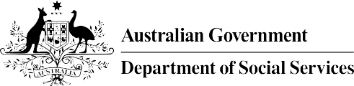

Global Sisters

Unlocking women’s economic potential
This case study is designed to help those interested or engaged in impact measurement by providing insights into the learnings from the development and ongoing evolution of Global Sisters’ Outcome and Impact Measurement (OIM) processes.

Key take outs
- Be prepared to evolve – regular assessment of their approach to Outcomes and Impact Measurement (OIM) allowed Global Sisters to identify what was and wasn’t working and helped them to refine their approach.
- Look at data collection from different perspectives – by thinking about collecting data from a participants perspective, Global Sisters identified ways and times to collect data that made sense to their participants to support the accuracy and useability of the data.

Integrate OIM into business planning – evidence-informed program design and development was supported through implementing ‘Rapid Evaluation’ for new initiatives that allows new initiatives to be adapted quickly to better meet targeted outcomes.
- OIM requires commitment, appropriate skills and resourcing – Global Sisters have had a commitment to OIM since the organisation was established, led by senior management and advisors with experience in measuring and reporting outcomes and impacts. Receiving funding for a Social Impact team has allowed them to increase their expertise and skill set.

Supporting women to achieve financial independence
Global Sisters provides women opportunities to improve their financial situation by working with them to develop business opportunities that allow participants (called Sisters) to be self-employed.
Around 1.8 million women in Australia are unemployed or underemployed, with women over 65 being the fastest growing homeless demographic and 250,000 single mothers receiving parenting payments.
Global Sisters works with women across Australia who are unemployed or under-employed due to systemic and structural barriers including single mothers, carers and older women. They help these women achieve financial independence through developing business acumen and skills, helping them build and grow their business idea.
The organisation was launched in 2016 and offers a three-year program at no charge to women. The program provides end to end support for Sisters who: are keen to explore if a self-employed business is for them; already have a business idea; or who own an existing business and are wanting to grow into a profitable and successful enterprise.
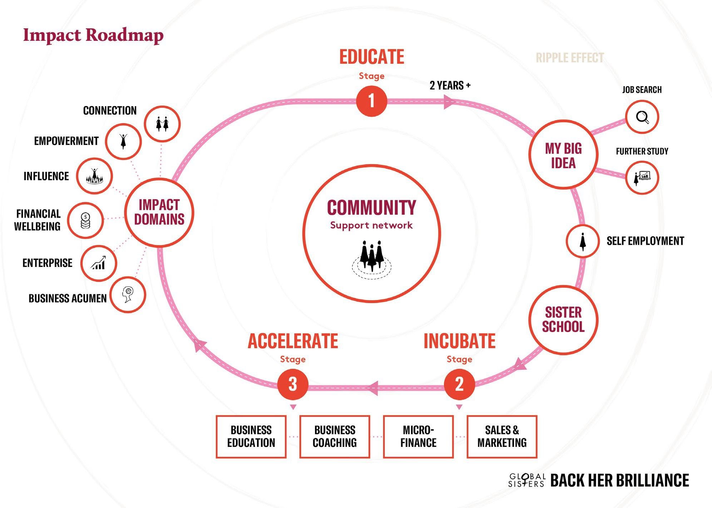
“Global Sisters exists to make business possible for all women and to create a world where every woman is provided the opportunity to build her own economic future.” - Global Sisters 5 Year Growth Strategy
Sisters access programs, support, networks and coaching across their time with Global Sisters that aim to achieve impacts across six areas:
- Business acumen - increase knowledge and skills to operate a viable business
- Financial wellbeing - increase a Sister’s income and financial resilience
- Enterprise - help Sisters to launch and grow their business
- Empowerment - increase a Sister’s sense of purpose and confidence
- Influence - increase the number of female role models within business and in the community
- Connection - reduce social isolation and help Sisters connect with other businesswomen.
Global Sisters is seeking to grow considerably over the next five years through developing ten regional clusters to increase the number of communities in which the program operates from 13 in 2020 to 60 in 2025. This is expected to increase the number of Sisters impacted exponentially from around 1,300 in Q1 2020 to 43,000 by 2025.
This growth will be enabled through the expansion of the current program into new communities, developing new ways for the program to be operated across regions and digital transformation that will allow Sisters to access the program no matter where they live via a virtual platform.

A commitment to understanding impact
When Global Sisters was established in 2016, senior management identified that being able to measure and report the outcomes and impact that Sisters were achieving was key to supporting the change that the program aims to achieve in women’s lives. The Global Sisters Social Impact Framework © initially identified 20 impact domains which were refined down to 5 domains (business acumen, financial wellbeing, enterprise, empowerment and influence) with measurable outcomes for each domain. A sixth domain, connection was introduced in 2020.
Focussing on outcome and impact measurement early in the implementation of the program allowed Global Sisters to evaluate the various elements of the program and to understand their impact and effectiveness - including hearing directly from Sisters on their experience. This information was also vital to help the organisation approach funders with clear evidence of the effectiveness of the program and what women are achieving as a result.
“Through the start-up period we learnt a lot around the specific needs of our target cohort, the program model, how to ensure impact and the requirements for scale.” - Global Sisters MEAL Framework 2020
The data collection to support the Social Impact Framework aimed to track a Sister across their time at Global Sisters and beyond, with regular surveys approximately every three-months and qualitative one-on-one interviews with Sisters, called Sister Chats. This provided information that supported Global Sisters to produce annual Impact Reports to communicate the outcomes that Sisters were achieving throughout the program.
As the program works with Sisters for around three years, it took some time for data to be collected and reported on the latter stages of the program and the ultimate delivery of outcomes and impact, and for Global Sisters to identify what of the approach to outcome and impact measurement was and wasn’t working.
Over time, several areas for improvement to the Social Impact Framework were identified:
  - Streamlining: opportunities to streamline the approach to collecting data. The initial approach collected data at 12 points across a Sister’s journey. This led to some survey fatigue, with surveys going uncompleted, or with incomplete responses.
  - Contextualising: revising the surveys that Sisters were asked to complete to help make them easier for Sisters to understand and making them more applicable to a Sister’s situation and experience of the program.
  - Informing and listening: helping both Sisters and on-the-ground staff understand why data was being collected.
  - Measurement and reporting: reflecting the consistent feedback received from Sisters that community and social connection was a key outcome of their involvement in Global Sisters.
These findings provided several opportunities to improve the usefulness and completeness of the data. It also demonstrated the need for qualitative stories of Sisters to support the data to provide an overall picture of the impacts being achieved across all Sisters. The individual experience of Sisters could also provide valuable information to support continuous improvement of the program as a greater depth of information would be available to support decision making.

A new approach
Global Sisters undertook an organisational wide review throughout 2019. This review helped support the development of a Five Year Growth Strategy and also included an update to the Social Impact Framework to ensure that the approach to outcome and impact measurement supported the growth and scalability of the program. It also provided an opportunity to implement some of the areas for improvement in the Framework. The updated Social Impact Framework was launched in early 2020 and identified five change areas and their related outcomes.

Change | Long-term outcomes
Women finding economic freedom through self- employment | - Economic freedom  - Self-determination
Women as change agents | - Women ‘standing tall’ and role-modelling strength, purpose and resilience  - Increasing leadership in family and community
Women increasing their independence | - Reduced reliance on Government support
Women creating vibrant communities | - Increased social capital  - Positive health outcomes, particularly mental health  - Community-level socio-economic development
Women as valued economic participants | - Increased employability  - Increased value of business
The Social Impact Framework is supported by a Monitoring, Evaluation, Accountability and Learning (MEAL) Framework. The MEAL Framework aims to:
- develop common understanding and processes for monitoring and evaluation
- streamline reporting
- support accountability to various internal and external stakeholders
- support and value the diversity of impacts, programs and Sisters.

Development of a new OIM approach
Global Sister’s updated Social Impact Framework and MEAL Framework were developed in late 2019 and early 2020. This process took place in tandem with an organisation-wide review of the program to support significant growth in both the number of Sisters in the program and innovation in the way that the program would be delivered in the future.
Having these two processes running side-by- side allowed Global Sisters to incorporate the discussion and identification of key outcomes and impacts into the new program design and also provided an opportunity to address some of the issues that had been identified with the previous Social Impact Framework. The Global Sisters team that developed the new Frameworks identified several factors that were key in the creation of the new Frameworks:
  - Improving data quality through a human-centred design process and communicating a clear value proposition
  - Supporting evidence-based program design and development by including ‘Rapid Evaluation’ into OIM processes for new initiatives
  - Continuing the organisation’s commitment to OIM and deepening internal OIM capability to make the most of the data collected.
“It’s not just us collecting data but Sisters can see their journey, their journey within a cohort – compared to or being encouraged by how they’re sitting alongside other Sisters doing the same kind of business.” - Global Sisters staff member

Human-centred design process
The team thought strategically about data collection and adopted an approach that sought to make it as easy and seamless as possible to collect data from Sisters during their time in the program. By looking at it from a Sister’s perspective, including through direct consultation with Sisters, they were able to identify that surveys should be customised to collect information on program experience and Sister outcomes at key milestones when Sisters were transitioning from one phase of the program to another.
This meant that the organisation would be undertaking half the number of surveys (down to 6 from 12). However, it allowed them to be more tailored in what they asked Sisters and made the most of a natural pause point in the program to help Sisters to reflect on their experience of the previous phase and to identify the progress (or outcomes) that they had made.
It is hoped that this approach will help improve the completeness and quality of the outcome and impact data that Global Sisters receives and will therefore also improve their ability to report on their outcomes and impact.
"Really understanding people’s motivations and when is going to work, not just in terms of our longitudinal interest, but when’s really going to work for them.” - Global Sisters staff member

A clear value proposition
The human-centred design process helped Global Sisters to identify when it made sense for them to collect data but they realised that they also needed to ensure that both Sisters and internal staff were clear on why they were collecting data.
For Sisters, the inclusion of data collection within milestones on their journey through the program provides a natural reflective opportunity. Sisters can look back on what they have done in the previous phase, celebrate their successes and identify barriers they have encountered. This allows Global Sisters to collect the data they need, and to also to provide value to Sisters through a supported reflective process.
Sisters’ involvement in data collection is also supported by the need to complete the survey to be able to proceed to the next phase of the program. This provides an additional incentive to complete the survey without placing too much burden on Sisters. Plans are in place to monitor this process to ensure that completion of these surveys does not become a barrier to Sisters being able to progress in the program.
The social impact team identified that there was a need to educate staff around why data needed to be collected and what value it provided to both individual staff members and the wider organisation. With this in mind, a one-page fact sheet was created for staff that work with Sisters and are responsible for collecting both administrative and outcome data. The fact sheet outlines the importance of collecting demographic data and how this information is used and helps to support the ongoing operation and funding of the program.
These efforts help to create an understanding for the stakeholders providing data about the value of that data. It is hoped that this will improve data quality and accuracy.

Supporting evidence-based program design
The use of ‘Rapid Evaluation’ processes is integrated within the new MEAL Framework to ensure that program design and development is informed by OIM data. Rapid Evaluation provides a structure for a new or pilot initiative’s relevance, appropriateness, efficiency and effectiveness to be assessed in a timely way to support continuous learning and improvement.
The steps undertaken during Rapid Evaluation of a pilot program include:
- Social Impact Teams meets with program leads
- Intent & outcomes of program identified
- Data collection & reporting methodology identified
- Real-time data collection during program implementation
- Rapid evaluation reporting
- Learnings & recommendations are identified at both operational and leadership levels
- Learnings & recommendations implemented.
The approach requires early consideration of the expected outcomes (particularly in the short to medium term) of a program and identification of possible sources to collect data on how successful the initiative has been in achieving those outcomes.
Global Sisters in-house Social Impact Team work closely with the teams implementing new initiatives to guide and inform this process and several tools have been produced to help support this. These tools include an evaluation template that helps to guide the team implementing changes through the key steps and questions in the Rapid Evaluation process. A survey question matrix has also been developed that provides possible evaluation questions for each of the six areas of impact to help streamline the process for data collection.
This process also identifies what data and outcomes can be included within the Rapid Evaluation framework and what would be more appropriate for a longer-term evaluation. This is important distinction to ensure that the intended purpose of the Rapid Evaluation process is clear and additional data collection or reporting requirements do not place an undue administrative burden on staff.
Once an initiative has been established, the Rapid Evaluation reporting is provided to key decision makers in a timely way. This process allows for iterative development of initiatives that is based on the evidence around the outcomes to help continuously refine programs based on the data.
“In the pilot period it’s important that we are taking time to evaluate what we are rolling out, in real time. This means we make time in the program year to learn and adjust.” - Global Sisters MEAL Framework 2020

Continued commitment to OIM
Measuring and reporting outcomes has always been a key focus for Global Sisters. Their leadership team has significant experience and interest in OIM and this led to a commitment that OIM activity should be prioritised and supported throughout the organisation. This was further supported by the establishment of a Social Impact Team.
The focus on OIM is supported at both strategic and operational levels. At a strategic level, the Social Impact Team ensures that the organisation is clear on the outcomes it is trying to achieve. Reporting, including the 2020 Impact Report provide transparency to external stakeholders, including funders and supporters and present evidence about the impact and effectiveness of the program.
At an operational level, the Social Impact Team work closely with initiative leads to implement the Rapid Evaluation process and to ensure that the initiative is clear on the outcomes they are aiming to achieve and how they can identify (both in the short and longer-term) if they are achieving those outcomes.
The team has also been able to provide expertise to help in the development of research instruments and reporting software to support quality data collection and reporting.
The Social Impact Team has recently expanded to three people as a result of grant funding provided by the Australian Government Department of Social Services. This has provided increased technical and operational support to the organisation’s OIM efforts.
While not all enterprises have the resources available to establish a stand-alone social impact team, it is critical that an operational and strategic approach to social impact is embedded within an organisation to support successful OIM.
“Impact measurement and knowing what our outcomes are, our theory of change and all of that stuff was just a given…it has to be done.” - Global Sisters staff member

The future
Global Sisters is at the start of their journey in implementing their updated Social Impact and MEAL Frameworks. It is hoped that these frameworks will help to support proactive outcome and impact measurement rather than the more reactive approach that emerged within the start-up phase of the organisation.
This new approach provides several opportunities to support the organisation at both a strategic and operational level. At an operational level, Global Sisters is planning to identify opportunities to integrate their Customer Relationship Management (CRM) software and impact data collection to help streamline data collection and reporting and to reduce manual handling.
At a strategic level, the reporting on outcomes and impact is expected to provide an important evidence base to support the organisation’s continued fundraising efforts. It will also support an increased focus on systemic advocacy to help Global Sisters to advocate for policy changes to help support women to achieve financial resilience and security. Most importantly, a deeper understanding of outcomes and impact can empower Sisters to achieve financial independence and resilience.

More information?
For more information on Global Sisters visit globalsisters.org and to find out more about the impact the program is having view the 2020 Impact Report.
This case study is the first in a series of six-monthly case studies following Global Sisters’ approach to outcome and impact measurement (OIM) and how they use OIM to support growth and scale.
The case studies are funded by the Department of Social Service (DSS) to provide information to the social impact investing sector to better understand, define, measure and communicate their non-financial social outcomes and impact.

Global Sisters (2020) Global Sisters 5 Year Scale Strategy

