Global Sisters: Telling the big picture story
This case study is designed to help those interested or engaged in impact measurement by providing insights into the learnings from the development and ongoing evolution of Global Sisters’ Outcome and Impact Measurement (OIM) processes.

Key take outs
- Global Sisters have defined the expected broader impact of their programs, known as the Ripple Effect, to help explain how their work at an individual level has flow on impacts to Sisters’ communities and wider society.
- Global Sisters are extending their OIM to report their longer-term outcomes after several years of focusing on short to medium term impacts.
- While their OIM helps communicate impact to external stakeholders, Global Sisters also use impact reporting to inform continuous improvement of their program and the way they measure and report on their impact
- Co-design of their impact domains with Sisters’ provided a solid foundation for OIM activities and allows Global Sisters to be confident that they are measuring the appropriate longer-term outcomes.
- The use of qualitative data and storytelling helped fill gaps in outcomes data and will provide clarity to help attribute broader systems change to Global Sisters’ work with Sisters.

About Global Sisters
Global Sisters provides women opportunities to improve their financial situation by working with them to develop business opportunities. This aims to allow participants, called Sisters, to be self-employed and financially resilient.
The not-for-profit organisation works with women across Australia who are unemployed or under-employed due to systemic and structural barriers including single mothers and older women. They make business possible for all women and create a world where women have the opportunity to own their economic future.
The organisation was launched in 2016 and offers a flexible, modular based program where Sisters choose what they need, when they need it. It is bespoke and tailored to Sisters’ individual barriers, circumstances and stage of business. The program provides end to end support for Sisters who:
- are keen to explore if a self-employed business is for them
- already have a business idea
- want to grow their existing business into a profitable and successful enterprise.
Global Sisters supports Sisters through a roadmap of programs across three stages: education, incubation and acceleration.
As Global Sisters state in their Monitoring, Evaluation, Accountability and Learning Framework “Impact addresses the ultimate significance and potentially transformative effects of the programs. It seeks to identify social, environmental and economic effects of the intervention that are longer term or broader in scope than those already captured under the effectiveness criterion. Global Sisters refers to this as the Ripple Effect.”

The Ripple Effect
Global Sisters’ (OIM) is guided by their Monitoring, Evaluation, Accountability and Learning Framework.
The Framework includes a Theory of Change bringing together the direct impact Global Sisters are aiming to have on Sisters, their families and communities, and systems change and transformation outcomes. The combined impact across these areas is identified in what Global Sisters calls the Ripple Effect.
The Ripple Effect identifies their impact is not only improving Sisters’ lives, but benefits are also rippling out to their families and communities. These include:
Financial Ripple Effects of Sisters reinvesting business income back into their families and communities
- Sisters supporting others to break down barriers
- Role modelling and inspiring others
- Paying it forward through responsible business
- Enhancing the visibility of female-run business principles within a male-dominated sector.
The Global Sisters Impact Roadmap identifies the different impacts achieved by Sisters.

Global Sisters Impact Roadmap
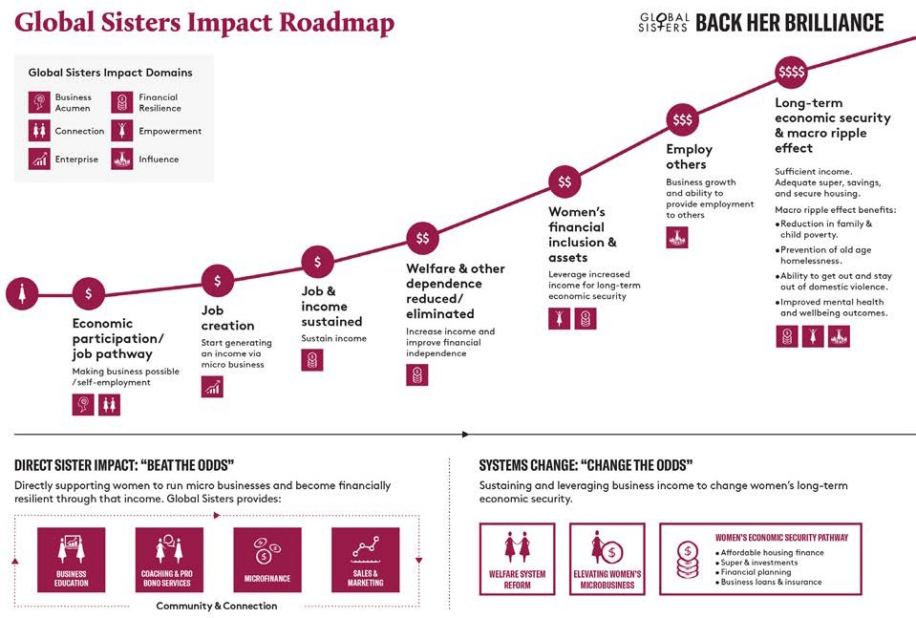
Global Sisters has learnt that when you support a woman, this naturally ripples out to benefit others. Historically, much of Global Sisters reporting focuses on their six impact domains of Business Acumen, Enterprise, Financial Resilience, Empowerment, Influence and Connection. These domains focus on the direct impact on Sisters.
However, qualitative data shows a pattern amongst Sisters that early in their journey, they express plans to build up a business that will positively help others, either through the way they run their business in line with good business principles, through hiring people from groups that experience barriers to employment, by reinvesting their profits back into a social cause, or by leading the way and removing barriers for other women who will follow them. Sisters are therefore using the positive impact from Global Sisters to positively impact their families, community and society as a whole.
This Ripple Effect is also prevalent at the systems change level, with Global Sister’s three systems change priorities focused on welfare reform, economic security pathways and advancing micro business.
Global Sisters’ direct impact, combined with the Ripple Effect of their systems change initiatives is expected to contribute to the alleviation of four macro-level society issues. These are:
- Family and child poverty
- Mental health and wellbeing
- Domestic violence
- Old age and single mother homelessness.
Measuring Global Sisters’ attribution to their direct impacts as outlined in the impact domains, the Ripple Effect resulting from these, and their contribution to these four macro-level issues is the focus of their current and future longer-term impact measurement.

Global Sisters social impact framework
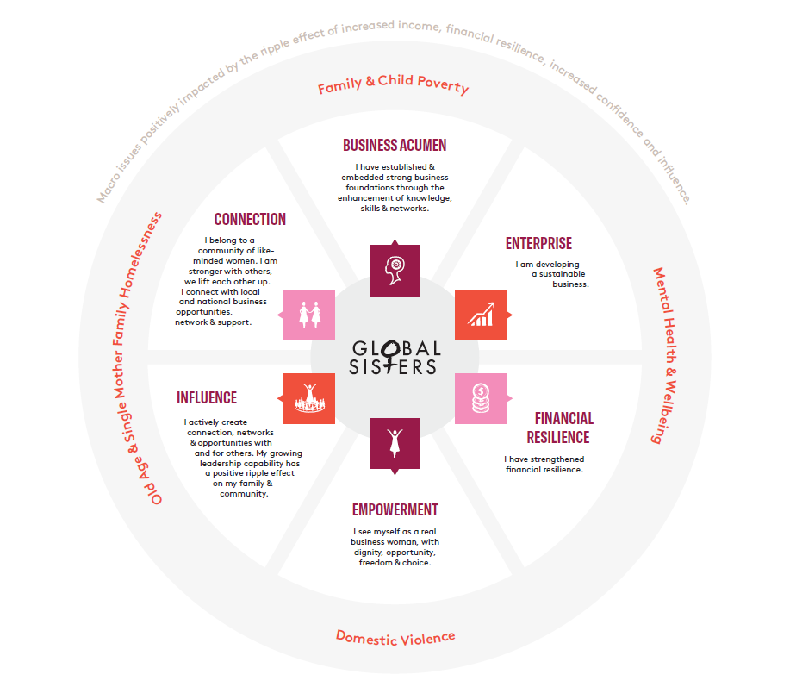

Global Sisters’ approach to measuring long-term outcomes
Global Sisters’ approach to OIM has a number of strengths that will support their attempts to measure and report on their long-term outcomes.

Clear purpose acts as a guide
Global Sisters operates with a strong vision and purpose.
The organisation’s overall contribution is centred around longer-term systemic issues, such as women’s economic participation, income inequality and child poverty. Their Theory of Change developed iteratively, reflecting the different phases of their development and growth. However their purpose has remained the same throughout.
Global Sisters management says “As an organisation, we are so crystal clear on what we’re trying to achieve. Even though our program can be very complex and there’s so many different facets, actually, what we’re trying to do is very straightforward.”
Global Sisters has developed a strong foundation against which all OIM is based. This ensures that all OIM activity is consistent and relevant to priorities of the organisation.

Adopting a phased approach
Global Sisters has adopted a phased approach to their OIM.
When the organisation was launched in 2016, they began by focusing on measuring and reporting the short to medium term impacts for Sisters against their impact domains. This provided evidence that the program was indeed achieving their intended impacts for Sisters.
After the initial establishment of their OIM Framework, Global Sisters refined their OIM approach through the development and implementation of their Measurement, Evaluation, Accountability and Learning Framework. The Framework was developed as part of an organisational-wide review and aimed to:
- develop a common understanding and processes for monitoring and evaluation
- streamline reporting
- support internal and external accountability
- develop a framework which recognises, accommodates and values the diversity of Global Sister’s impact, programs and target cohort.
Following the implementation of the Measurement, Evaluation, Accountability and Learning Framework throughout 2020 and 2021, Global Sisters then moved their focus on how they would approach the measurement and reporting of their longer-term outcomes.
Global Sisters management said “Our Impact Framework was really focused on those six domains because we wanted just to be able to get those runs on the board and create the impact that we intended.”
By taking a systematic approach, Global Sisters were able to support their initial start-up and growth phases with evidence of their impact, enabling them to scale their activity beyond the initial proof of concept with confidence and a strong foundation. Testing the OIM framework before attempting to measure and report long-term outcomes provides Global Sisters with confidence that their approach to OIM is appropriate and relevant.

Global Sisters phased approach
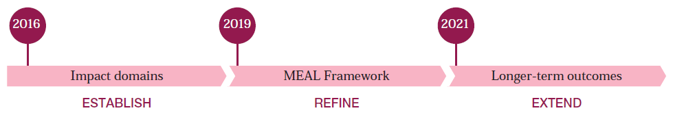

Continuous improvement
Since establishing their impact reporting, Global Sisters has retested the validity of their impact framework on several occasions, and has refined their approach based on available evidence, and particularly the feedback and experience of Sisters. The introduction of the Measurement, Evaluation, Accountability and Learning Framework in early 2020 established common monitoring and evaluation processes. This helps Global Sisters to evaluate their “own impact and progress in real time through rapid evaluations and ongoing monitoring”.
This approach allows Global Sisters to constantly test their activities and outcomes against their intended impact to support a strong focus on continuous improvement. This focus is embedded across their operational activities.
For example, an organisation-wide review process in 2019 ratified the existing impact domains and added a sixth domain regarding connection. Additionally, analysis of the feedback received from Sisters and their experience of the program provided empirical insights on the way Sisters go through the program. While the program is delivered through business education, incubation and acceleration phases, Sisters were empowered to move through the program at their own pace and access support at critical junctures within their business development. Data received as part of their OIM activity confirmed and gave credibility to what Global Sisters had observed, in that Sisters’ journeys were not linear and that Sisters were developing and growing their businesses in a slower but more sustainable way. This provided important evidence on the way that Sister-led microbusiness develops in contrast to mainstream start-ups.
This led Global Sisters to refine the way they communicate regarding their program, adapt certain programs and their monitoring and evaluation processes to account for each Sisters’ individual experience of the program.
By regularly revisiting their impact domains, Global Sisters can have confidence that their longer-term outcomes are appropriate and will provide a relevant indication of the impact they are having on Sisters and the wider community.

Co-design with key stakeholders
Global Sisters program of support and impact domains and OIM activity were developed in response to comprehensive consultation with Sisters and the wider Global Sisters community. Since they were introduced, outcomes have been sense-checked against qualitative data regarding Sisters’ experience and impact data.
This led to the addition of a sixth impact domain – Connection based off feedback from Sisters that their participation in Global Sisters had increased connection and networking with other women in the community.
Engaging in a meaningful co-design process created alignment between Global Sisters’ outcomes and the goals of Sisters themselves. By speaking directly with Sisters, Global Sisters grounded their OIM activity in the change and impact that Sisters wanted to see, and had experienced, in the program. This set a solid foundation against which to measure and report outcomes and impact and is important to support the measurement of longer-term outcomes as it allows for consistency over time – a crucial component in observing longitudinal change.

Connection: Impact Domain and Indicators

Connection
- Community, support and opportunities.

Intended Outcomes
- Sisters are less isolated
- Sisters are connected with coaches
- Sisters are connected with likeminded business’ or business women
- Sisters are connected into business ecosystems
- Sisters are active members of our Global Sisters community
- Sisters are connected to funding opportunities
- Sisters receive pro-bono support.

Corresponding Indicators
- Sisters impacted through Global Sisters initiated Pitch events
- Networks
- Sister community members
- Pro-bono support ($)
- Access to finance
- Access to insurance
- Activities attended
- Engaged Sisters.
Note: Global Sisters' Indicators are currently being updated.

Use of qualitative data and storytelling
Global Sisters’ impact reporting has a significant focus on qualitative data, including Sister Stories, which will assist in communicating long-term impact.
In combination with the use of quantitative survey data, Global Sisters uses interviews and storytelling to build rich stories of the program’s impact on Sisters’ lives as well as their wider community.
Providing a platform for Sisters to tell their own stories is often mutually beneficial for Sisters in marketing their businesses. Sisters’ journeys and stories are showcased on the Global Sisters Social Impact Platform on the website, and are a key tool in communicating longer-term impact.
In keeping with their commitment to accessible reporting and centering Sister voice, Global Sisters has begun using interactive Journey Maps to demonstrate the impact on a Sister as she utilises the Global Sisters roadmap and moves through the business stages.
The Journey Maps are interactive, using video and text pop outs that are connected to qualitative themes so that the viewer can watch a Sister telling her own story about the impact of Global Sisters on her and her business. This humanises the data and provides depth of insights into the Journey of Sisters and the diversity of outcomes they have experienced.

Global Sister management said “One of the main principles for what we’re doing is telling our Sisters’ story…Things are so complex and quantitative data alone doesn’t provide that.”

Sister Journey Map
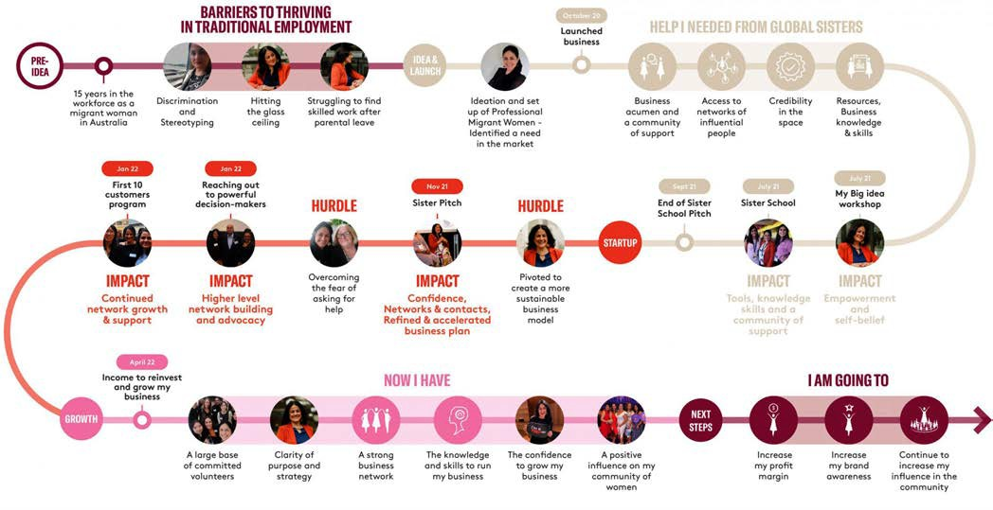
The use of qualitative data also helps address some challenges regarding attribution of outcomes. As with most social change programs, Global Sisters has noted that there are challenges in attributing wider systems change to their programs. When Sisters tell their own stories, it provides a greater, nuanced understanding of longer-term impact and outcomes and allows for more straightforward attribution.
For example, if a Sister identified that they had enough saved income to afford a house deposit predominantly due to their involvement in Global Sisters’ programs, a clearer process forms in connecting their individual outcome, and other collected survey data, to preventing old age homelessness.
Telling a story through qualitative data has immense value for OIM, filling in gaps that cannot be answered by quantitative measures and amplifying the voices of those who benefit most from Global Sisters’ activities

For more information on Global Sisters visit their website at globalsisters.org and to find out more about the impact the program is having view the Global Sisters Social Impact Platform.

This case study forms part of a series of case studies following Global Sisters’ approach to OIM and how they use OIM to support growth and scale.
The case studies are funded by the Department of Social Services (DSS) to provide information to the social impact investing sector to better understand, define, measure and communicate their non-financial social outcomes and impact.
Figures reproduced with permission.

