Guide to using the Families and Children Activity outcomes framework
The Families and Children Activity outcomes framework identifies the key outcomes that programs and services funded under the Families and Children (FaC) Activity should be seeking to achieve. It was developed by the Department of Social Services (DSS) to further strengthen its goal of achieving positive outcomes for families and children. It is anticipated that service providers will draw on the outcomes framework when planning and evaluating their programs, particularly when developing program logics or evaluation frameworks.
This document provides information on the components of the outcomes framework; that is, the outcomes that a program is seeking to achieve and the indicators of how well a program is progressing to achieve them. The final section provides guidance on selecting measures to collect data on the indicators.
Figure 1: Families and Children Activity outcomes framework
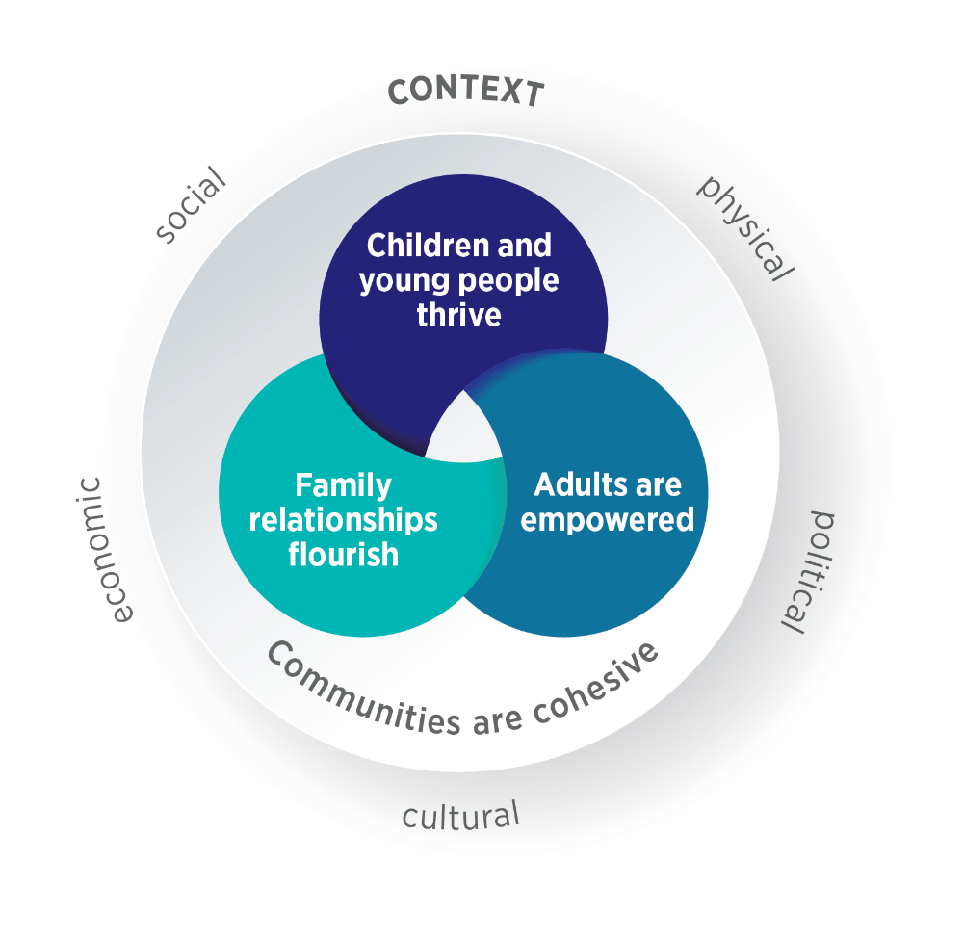

Outcomes
The outcomes in the framework fall under four aims:
- Children and young people thrive
- Adults are empowered
- Family relationships flourish
- Communities are cohesive.
The outcomes framework diagram depicts these aims as overlapping circles to acknowledge that they interact. Associated evidence-based outcomes are listed under each aim. The aims are embedded in the context of the social, cultural, physical, economic and political environment that FaC Activity service users are located within.
The aims and outcomes reflect all the different types of services and programs that fit within the FaC Activity. Not all of the listed outcomes will be relevant to all services, but all service providers should be able to identify at least one outcome that they are working towards.
These outcomes are often what a service would be expected to achieve in the long-term. A program logic model depicting the anticipated outcomes for a service or program in the short-, medium- and long-term can be used to guide the selection of outcomes from this framework.

Indicators
Indicators are things that can be measured and show progress towards outcomes. For example, improvement in the indicator ‘Increased proportion of children participating in community sport’ can show progress towards the outcome ‘Strong connections to social supports and community’.
Measuring indicators can show if a program is achieving its desired outcomes. It may also show if there has been no improvement and the program should be revised. This means indicators should be carefully chosen to be appropriate for the outcome you are aiming for.
Often several indicators may be needed to show progress towards a long-term outcome. The measurement of these indicators may be part of a staged evaluation process.
Several suggested indicators are listed under each outcome in the outcomes framework, and service providers can identify the ones that are relevant to their services. The list of suggested indicators is not comprehensive and service providers may also wish to develop their own indicators. Please note, in some cases, the same indicator is relevant to more than one outcome.
Where appropriate, indicators are presented in the direction of change that a service would hope to achieve. For example, one indicator might be improvement in a positive quality or aspect of wellbeing (such as ‘improvement in relationship quality’), while another might indicate a decrease in negative behaviours (e.g. a decrease in reports of bullying). In this context, outcomes and indicators are for measuring a service’s progress towards a goal, not for measuring the progress of an individual client. When measuring the change in an indicator, data are usually collected from all participants, then the score for the indicator is calculated and presented as a percentage or mean value for the group overall.
The same indicator can be measured in different ways. For example, indicators of school attendance could include an increase in the proportion of children who attend school regularly, or a decrease in the proportion who are absent for extended periods.

How to measure progress against an indicator
Data are needed to assess progress against an indicator. Data might need to be collected by the service or an external evaluator.
Data to measure progress against indicators can sometimes be gathered by administering validated tools to service users (usually prior to and following participation in a service). Validated measurement tools, when used correctly, provide stronger evidence because they have been tested to ensure they produce reliable, accurate results. However, validated tools will not be available for some indicators or may not be suitable within the context of some services or target groups. When this is the case, surveys or other forms of data collection may be used or developed to measure an indicator. Further information on selecting measurement tools can be found here.
Many FaC Activity providers are required to submit participant data to the DSS Data Exchange (DEX) using Standard Client/Community Outcomes Reporting (SCORE). A table listing how indicators could align with the Circumstance SCORE or Community SCORE domains within the DEX has been provided to assist in understanding how indicators might align with DEX SCORE. Validated measurement tools that have been translated into the DEX Translation Matrix are also provided. Goals SCORE have not been included as they do not apply to any specific outcome (and associated indicators) in the outcomes framework but instead can potentially apply to many outcomes depending on the specific client goals. Please note, the DEX domains and measures listed next to the suggested indicators are provided as a guide only and may not be relevant to the indicators selected for a specific service or program.
Here are some things to consider when deciding how to select an appropriate measurement tool or data source for showing progress against an indicator:
- Context that the service or program is operating within: This can include the funding, size or stage of development of a service. For example, if the service had been operating for some time, greater progress towards outcomes would be expected.
- Target group: Indicators need to be culturally relevant and appropriate for the target group. For example, ‘connection to country’ may be an appropriate indicator for programs focusing on cultural safety for Aboriginal and Torres Strait Islander people but may not be relevant for other client groups.
- Resources: That is, whether the resources and skills are available to collect and analyse the data, and whether the level of investment in collecting and analysing the data is warranted. For example, a 12-month program may warrant greater investment in measurement, monitoring or evaluation than would a one-day training course.
- The availability of data: Data may be available from other sources for some indicators, particularly community-level data. Before deciding to use a validated tool or designing your own measure, check to see if the required data have already been collected by others. If so, you may be able to use the same measure. This could help you compare the data you collect from program participants with the results for the community as a whole.
- How the results will be used: It is important to select indicators that will result in data useful to end users; for example, those who will make decisions about whether any changes are needed to the service based on the results.

Example: How the indicators could be used to measure change
A service works with children and many of its activities focus on improving peer relationships. Because of this focus, it selects the outcome ‘Positive mental health and wellbeing’ as relevant to its work. It also decides that Peer Relationship Quality is a useful and relevant indicator of how well it is progressing towards achieving improvements in ‘Positive mental health and wellbeing’.
The service now needs to decide how to measure its progress against this indicator. After considering possible measures of peer relationship quality, and the resources it has to implement the measures, it chooses the Strengths and Difficulties Questionnaire (SDQ). This measure is chosen because it has a ‘Total difficulties score’ and a ‘Peer problems sub-scale’ that are very relevant to this indicator and the work of the service. The SDQ has also been validated and widely used elsewhere with similar target groups. Another advantage of using the SDQ is that it is available on the DEX Translation Matrix.
To measure change, the SDQ is administered to parents of children participating in the service at two time points: before attendance and following last contact with the service. The two scores are then compared to identify any change. If a majority of the client group shows improvement in the Peer Problems Scale (which in this case means a reduction in peer problems) then this can indicate that there has been a desirable change for clients of the service. This is potential evidence of improvement in Peer Relationship Quality.

