## Case study

Doslyn (Lyn)

## Counsellor

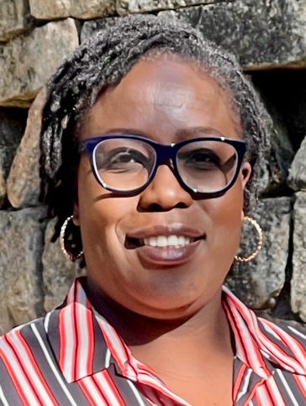

Working as a counsellor with a social work background has been a lifelong passion for Lyn.

She is currently providing counselling support for people with disability to work through issues of violence, neglect, abuse, and exploitation, as part of the support for the Disability Royal Commission.

“A counsellor supports people to have some space where they can offload and talk about what is happening in their life, without feeling judged – and without being judged,” says Lyn.

“When people come to me, I actively listen, validate their thoughts and feelings, and support them to reach their goals. For maximum and holistic support, I link people with other services based on their needs and I seek their consent before making the referrals.

"Working with people with disabilities who have experienced high levels of trauma has allowed me to use a strength-based approach, where I focus on the individual’s strengths, thereby promoting their wellbeing.

“We work as a team with the person being supported so that they find a way to cope with the challenges they will be experiencing. There is no hierarchy, we work side by side, with the person being the expert in their journey."

Lyn understands it isn’t always easy for people to take the first step to talk about their feelings or what they have experienced. Coming from a cultural community, Lyn knows that culture can sometimes present extra barriers to seeking support.

“For someone who is from a culturally and linguistically diverse community, there is a barrier where, in some cultures like mine, they prefer to keep information within their own families."

“People are scared to come out with their stories. There is embarrassment and shame. Culturally, it is seen as ‘*you can't hang your dirty linen in public*.’ I understand where they are coming from, and it is a matter of providing some reassurance that their information will be kept in confidence, while offering some education on the importance of seeking counselling when needed.”

Lyn takes pride in her ability to build trust with those who come to talk to her. Providing reassurance that what they say is confidential is a big part of what she does.

“When that connection is made with the counsellor, they might think ‘*why was I even scared to come out and talk?*’ So it is about empowering and building their confidence to advocate for themselves too.”

For some people, language can be a barrier to seeking help.

“Not all people can speak English as a second language - some people cannot speak English at all. Therefore, they would need to figure out how else to reach out to get the support they need. In my organisation, we use interpreters to ensure that non-English speakers are supported fully.”

Lyn encourages people with disabilities, or their family members or carers, impacted by the issues being explored by the Disability Royal Commission, to reach out for counselling support.

For more information visit: www.dss.gov.au/disability-royal-commission-support