You do not have to pay for a review.

You do not have to pay for a support person to help you.

The Australian Government will pay.

Has the National Disability Insurance Agency made a decision you do not like?

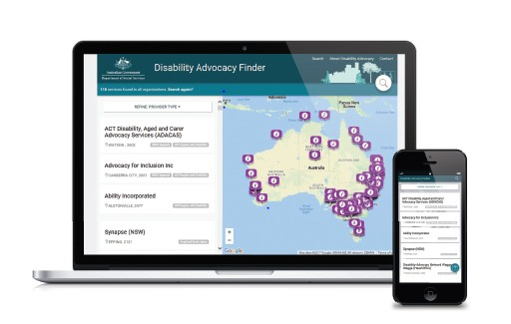
How to find find a support person to help me?

You can find a support person to help you by going to
https://disabilityadvocacyfinder.dss.gov.au.
How to get help

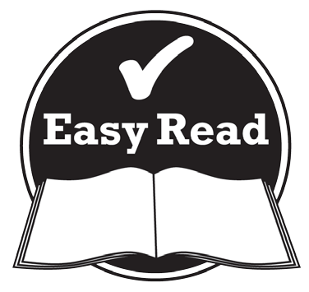
This booklet has pictures and words to show ideas.

More information

If you ask the AAT for an external merits review they can help you find a support person.

For more information about the help you can get if you want to have an NDIS Appeals review go to the website www.dss.gov.au/ndis-appeals

For more information about the Administrative Appeals Tribunal go to the website www.aat.gov.au
or call 1300 366 700.

For more information about the National Disability Insurance Scheme go to the website www.ndis.gov.au
or call 1800 800 110.

The Australian Government Department of Social Services wrote this. They are also called DSS.

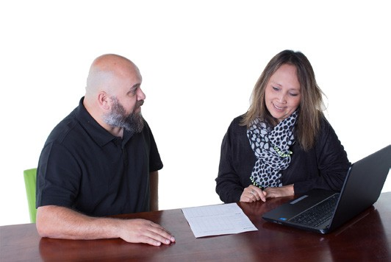
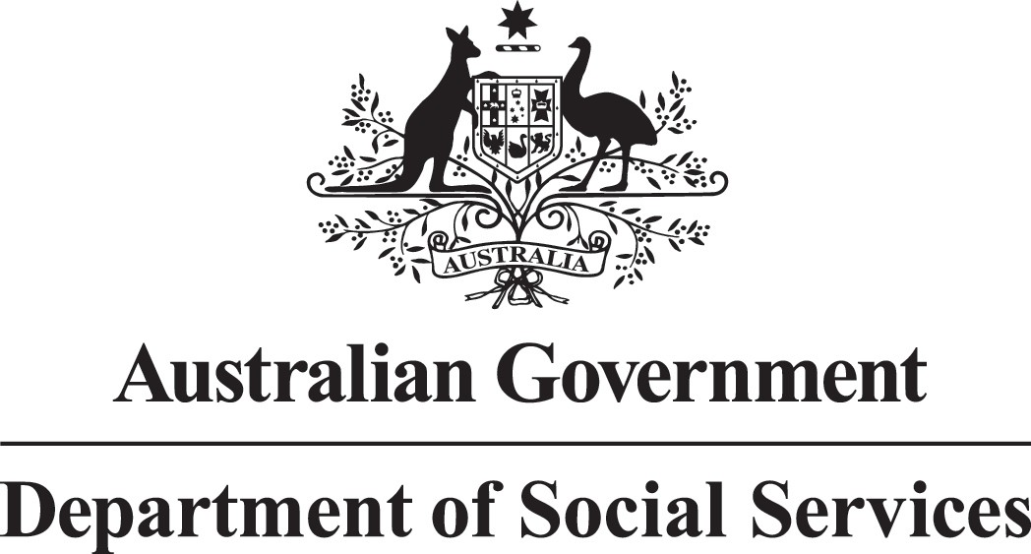
You can ask for help to read this booklet. Ask a:
- friend
- family member
- support person.

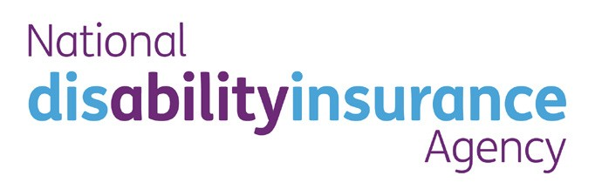
The National Disability Insurance Agency is part of the government. They are also called the NDIA.

They run the National Disability Insurance Scheme. This is also called the NDIS.

This Easy Read document was created by the Information Access Group using PhotoSymbols, stock photography and custom images.
DSS2199.11.17
The images may not be reused without permission. For any enquiries about the images, please visit www.informationaccessgroup.com

How to get help

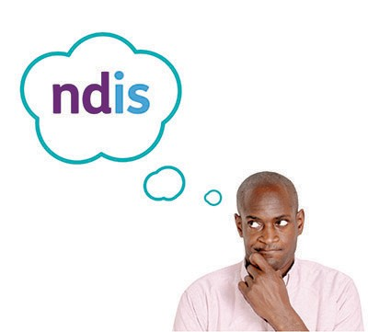

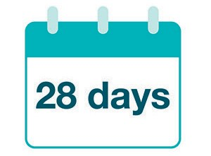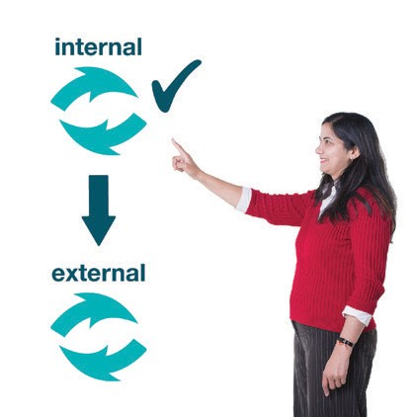

The NDIA make decisions about:

- if you will get support through the NDIS
- how much support you will get
- what kind of support you will get
- who will give you support.

If you do not like a decision the NDIA has made you can ask them to review it.

This is called an internal review.

If you still do not like the decision you can ask for another review.

This is called an external merits review.

You have to ask for an external merits review within 28 days of getting the decision letter from the NDIA.

You must have an internal review before you can have an external merits review.

You cannot ask the NDIA for an external merits review.

You have to ask the Administrative Appeals Tribunal for the external merits review. They are also called the AAT.

The AAT is an informal court. It checks many of the decisions made by the Australian Government. It is independent.

Who can help you?

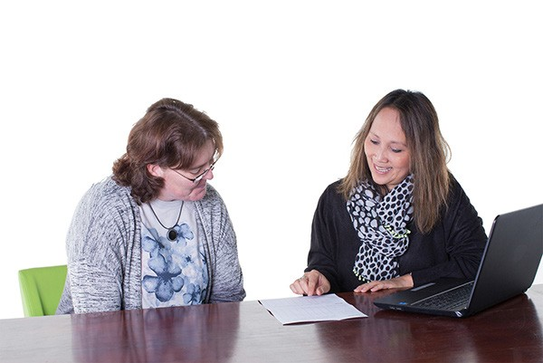

There are people who can help you if you decide to apply to the AAT. These people are called NDIS Appeals support officers.

They are not part of the NDIA or the AAT. They are independent.

They can:

  - help you understand what you need to do

  - help you get any documents or papers ready

  - give you advice and help you get ready if you want to speak to the AAT by yourself

  - go to AAT meetings with you

  - help you tell the AAT about your case if you want to.

They can also help you apply for legal help that you might need.
You might be able to get legal help if your case will not be easy to solve.

